ENVEX2026 Overseas Buyer Program

1. BIZ MATCHING – May 20(Wed) ~ 22 (Fri)
- ENVEX2026 provides all Registered Visitors with Biz Matching support.
- You can decide the date and the time to meet the matched exhibitors in advance.
 | VENUE | COEX Hall A
 | SUBJECT | For pre-registered overseas buyers  and others registered on-site
 | SERVICE PROVIDED | Interpretation services will be provided in line with the pre-scheduled meetings.
2. GUIDED HALL TOUR – May 20(Wed) ~ 22 (Fri)
※ MAY 20th 15:00, MAY 21th 11:00/15:00, MAY 22nd 11:00
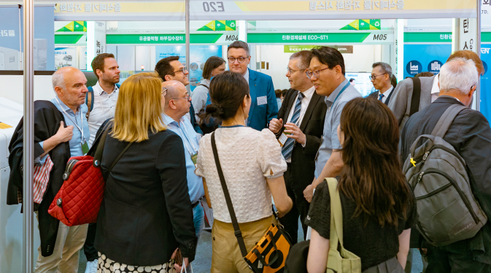 | VENUE | COEX Hall A
 | SUBJECT | For pre-registered overseas buyers  and others registered on-site
 | SERVICE PROVIDED | You will visit approximately 10 booths to each pavilion and be given detailed explanations on each exhibitor's products or services in English for about an hour.

3. SITE VISIT - MAY 22 (Fri) / 09:00 ~ 18:00
COURSE INFORMATION |  |  |  | *English guide offered
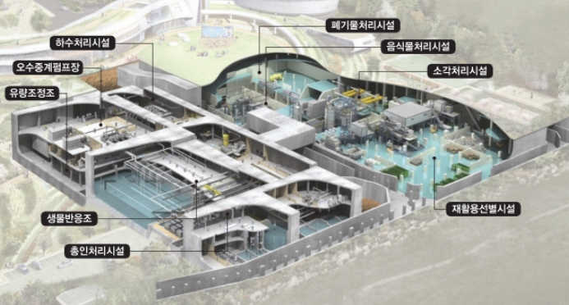 |  | Hanam Union Park & Tower
 |  | LOCATION: Hanam-si, Gyeonggi-do |  |  | DESCRIPTION: Waste management
The complex on Environment of 25 meter in the basement by up-to-date technologies such as for incinerating, resource recovery plant food, recycling selection, sewage treatment etc.
The complex on Environment of ground based for the culture & community for the residence such as water play area, physical training facility, gym , a tower of 105 meter in height foundation in 79,057㎡ in Hanam City with 303 billion KRW in June 2015.
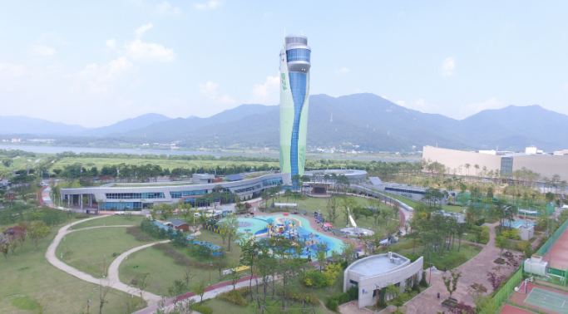
Time | Venue |  | Description |  |  | Transport
09:00~10:00 | From Convention Center To Hanam Union Park |  |  |  |  | Travelling by bus
10:00~11:00 | Hanam Union Park |  | Site Visit |  |  | Travelling by bus
11:00~12:00 | From Hanam to Seoul |  |  |  |  | Travelling by bus
12:00~13:00 | Lunch |  |  |  |  | Travelling by bus
13:00~17:00 | Seoul Tour |  |  |  |  | Travelling by bus
17:00~18:00 | To Convention Center |  |  |  |  | Travelling by bus
● The program may be cancelled if the minimum number of participants is not met.
● The detailed tour program schedule will be finalized later, and it is subject to change depending on the circumstances.
● Registration for the site visit will be accepted on a first-come, first-served basis.

